CHAT and YOGA

YOU ARE WELCOME TO THE GLEN DAY CARE CENTER ON TUESDAY 10TH FROM 11 -1
TO ENJOY A MORNING OF CHAT AND YOGA AS PART OF KERRY MENTAL HEALTH WELLBEING FEST.

Enjoy a chat with friends and some lovely homebaking

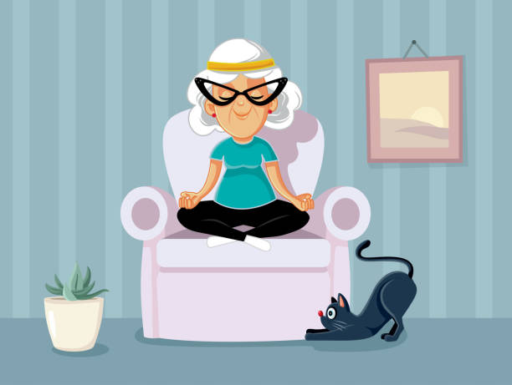
Relax with some light chair yoga

